Thought

Feeling

Action

Feelings  Here are some common emotions that people who know Mr. Anxiety feel:  EMBARRASSED: foolish, humiliated, self-conscious  ANXIOUS: worried, panicky, nervous, frightened  INFERIOR: worthless, inadequate, defective, insecure  LONELY: unloved, unwanted, rejected, alone, abandoned  HOPELESS: discouraged, pessimistic, defeated  ASHAMED: remorseful, bad, guilty  SAD: blue, depressed, down, unhappy  FRUSTRATED: stuck, defeated  JEALOUS: envious, distrustful  CONFUSED: befuddled, confounded, lost  HURT: wounded, upset, injured  DISAPPOINTED: let down, disillusioned, disheartened  ANGRY: mad, resentful, annoyed, irritated, upset, enraged |  |  | 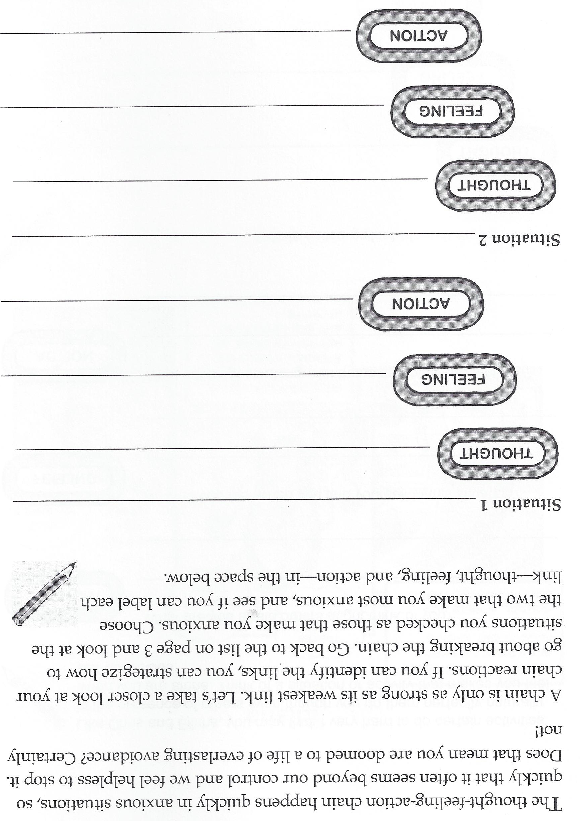
 |  |  | 9

Thoughts
Thoughts that go through our minds when we are presented with our own anxiety triggers are often called automatic thoughts, because they are ingrained in our brains and happen without us even thinking about them.
Action
When people face situations that make them anxious, avoidance is the most common action they take. Avoidance prevents the thing that they are afraid will happen from happening. The actions we take when faced with anxiety can cause us to feel isolated, discouraged, and sad.
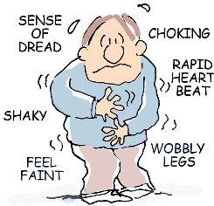

8 |  |  | 1

2 |  |  | 7

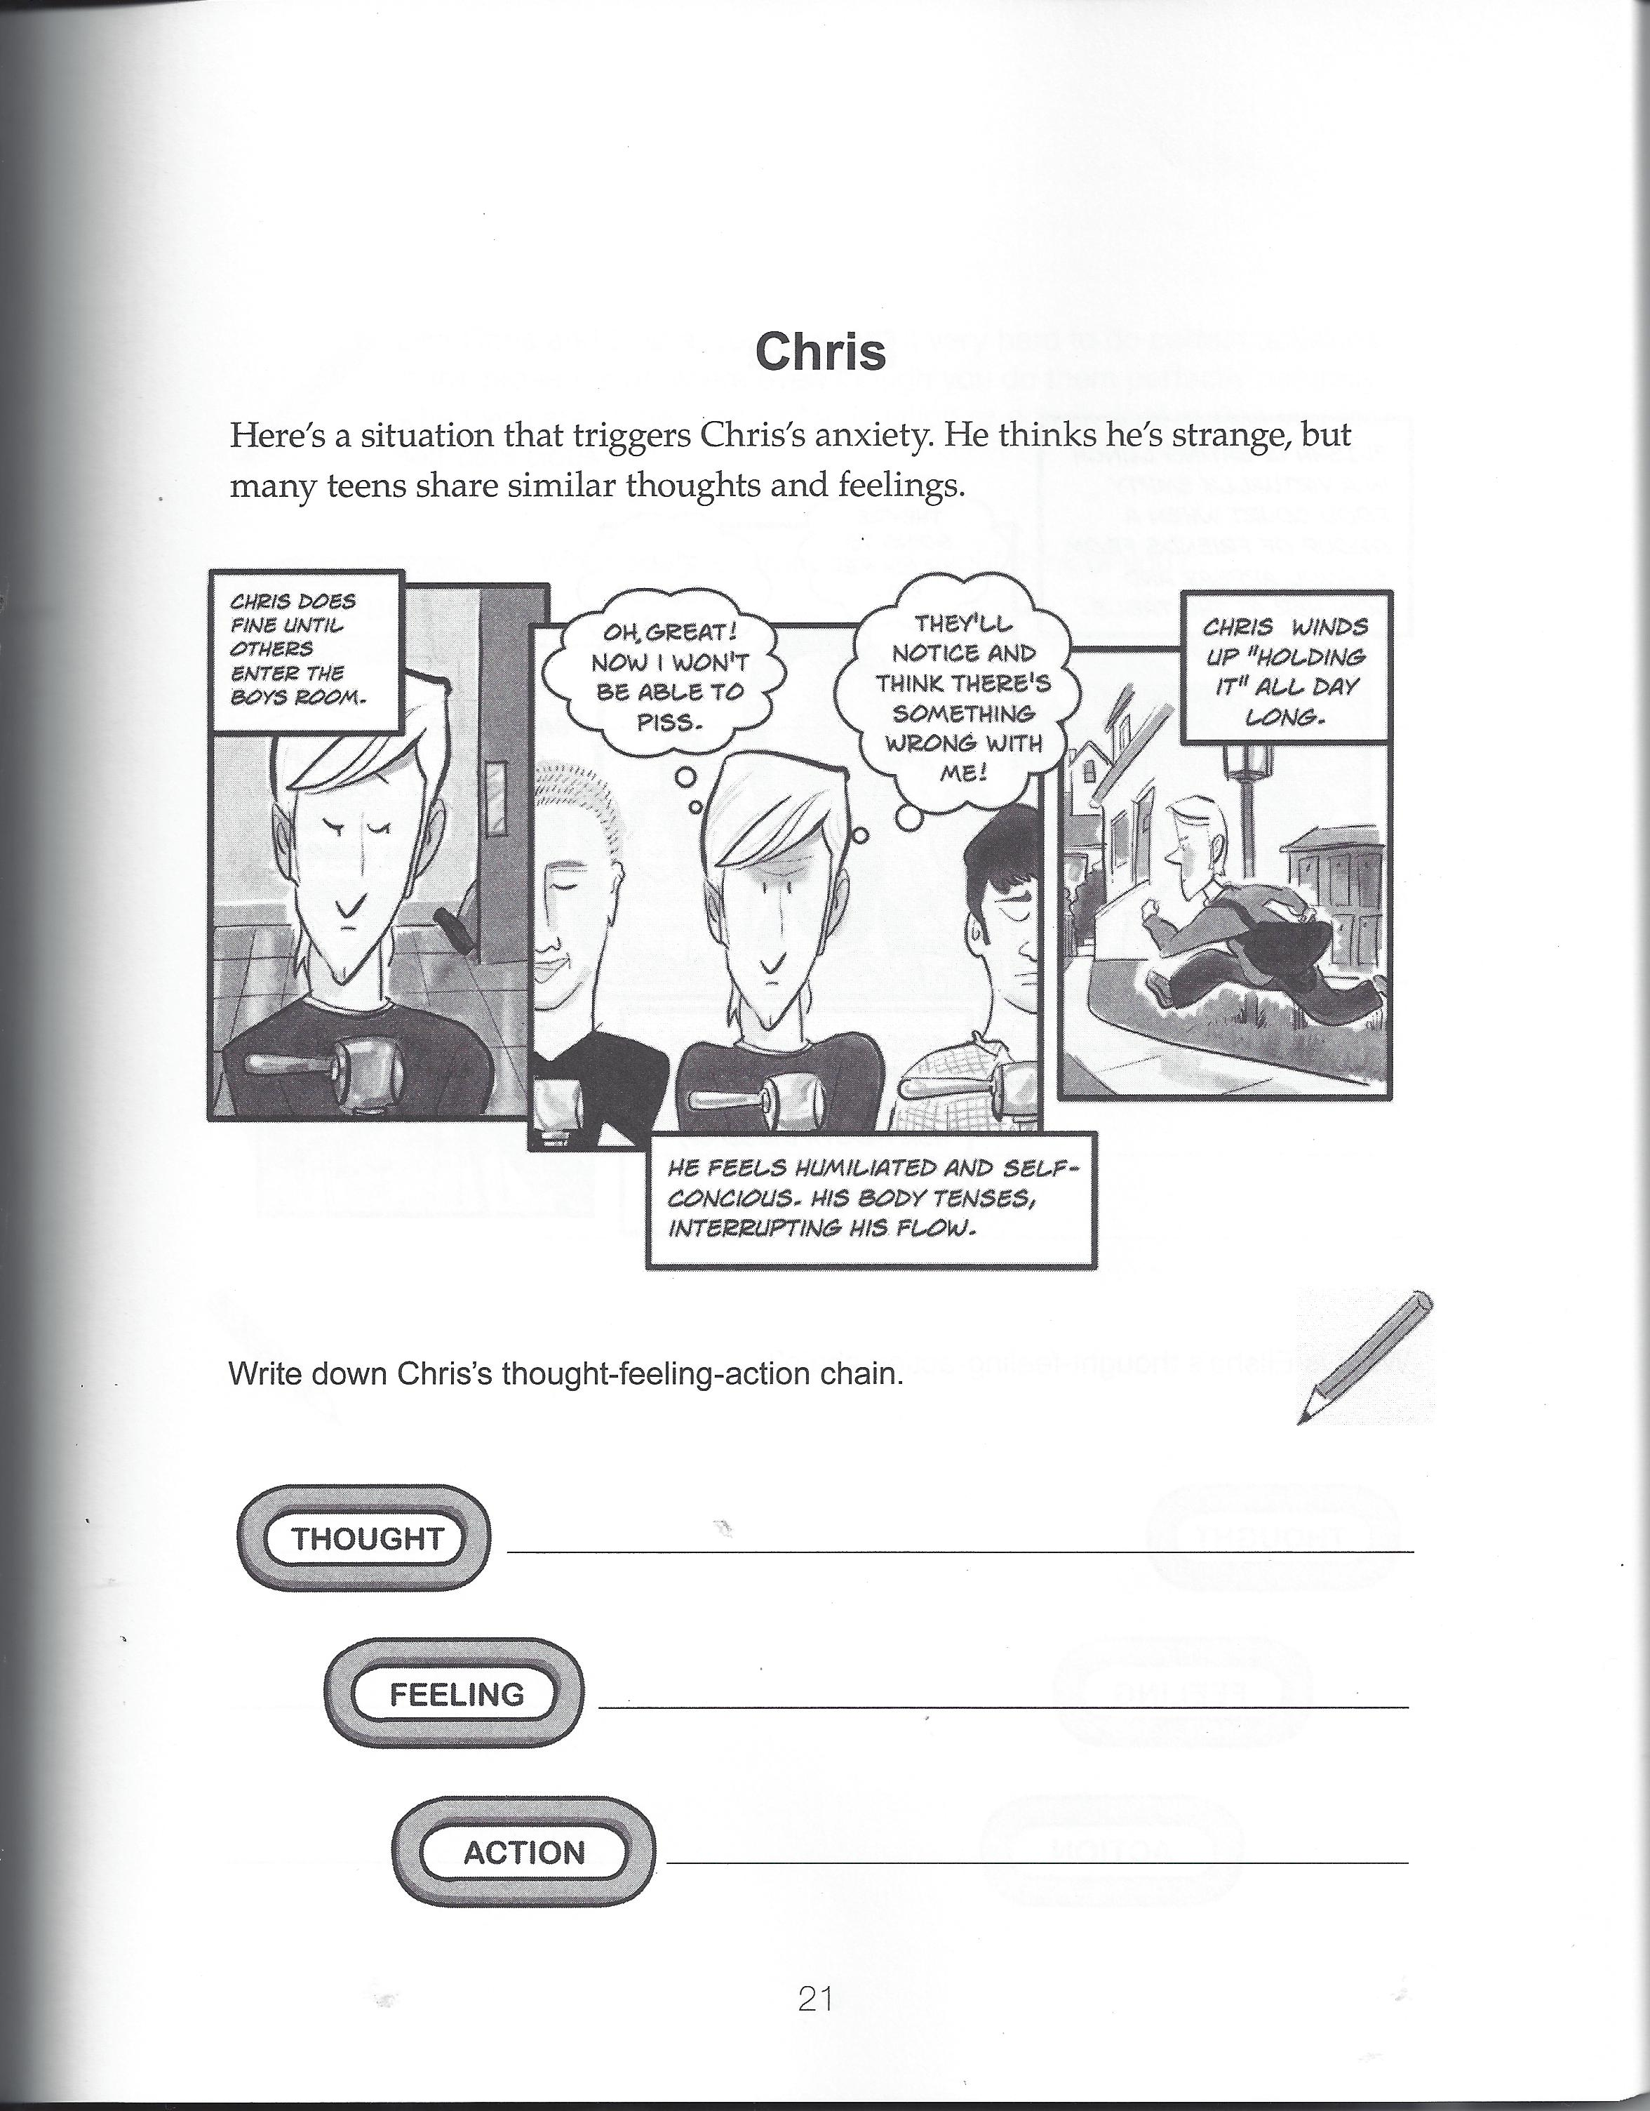
6 |  |  | 3

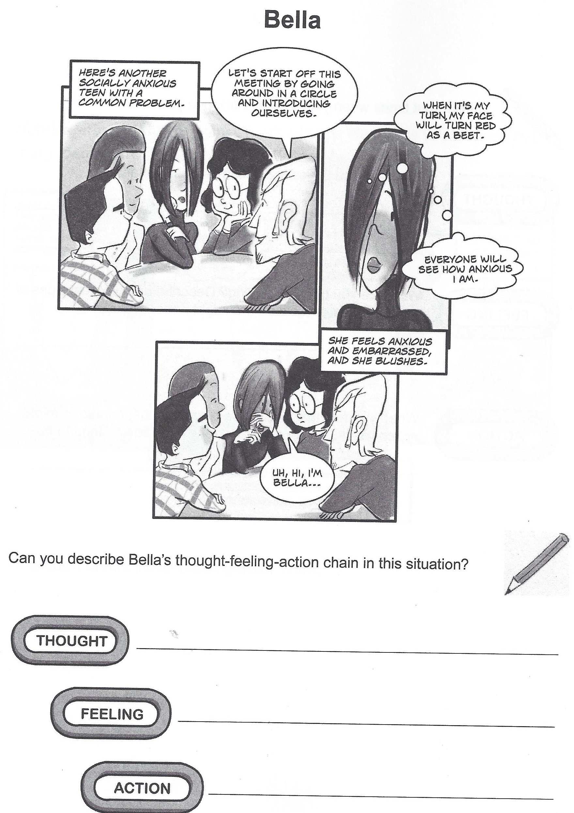
4 |  |  | 5

