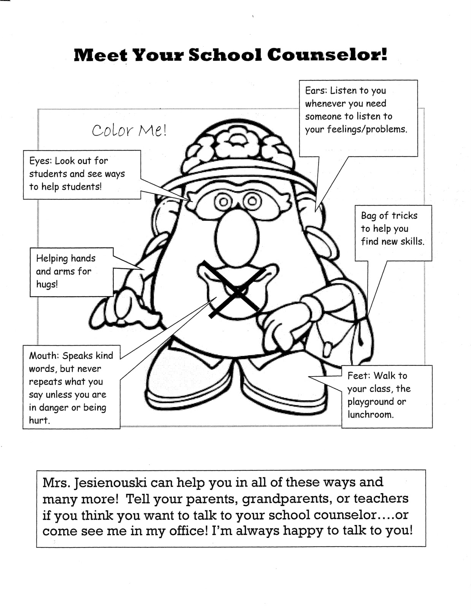

Mrs. Nielsen can help you in all of these ways and many more. Tell your parents, grandparents, or teachers if you think you want to talk to the school counselor. I’m always happy to talk to you!